LONGFORD MUNICIPAL DISTRICT

Corporate Affairs,
Aras an Chontae,
LONGFOIRT.

22nd February 2018.

To: Each Member of Longford Municipal District.

Dear Member,

You are requested to attend Meeting of Longford Municipal District to be held in the Council Chamber, Town Hall, Market Square, Longford, on Wednesday,
28th February 2018 at 4.00 p.m. to transact business, as set out on the Agenda hereunder.

Yours sincerely,
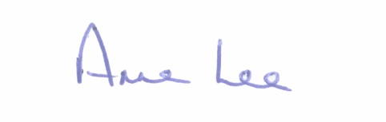

_______________
Anne Lee,
Meetings Administrator.

AGENDA

Prayer before meeting.

1. Confirmation of Minutes of the following meetings of Longford Municipal District–
- Committee Meeting held on the 24th January 2018.
- Monthly Meeting held on the 24th January 2018.
- Committee Meeting held on the 7th February 2018

2. Matters arising from Minutes.

3. Management Report - to follow.

4. Consideration of Schedule of Longford Municipal District Works - Report enclosed.

5. Presentation on Plan for Ballyminion Strategic Site.

6. Nomination of one member to –

(a) Business Incentive Scheme Committee.
(b) Board of Longford Pool Construction Ltd.

(to replace former Councillor Padraig Loughrey)

7. Discussion regarding the location of the Salt Barn at the Council Yard, Park Road.

8. Notices of Motions, submitted by Councillors, as listed hereunder -

Councillor Gerry Warnock.

“I am requesting that Longford County Council write to Minister Kevin Boxer Moran requesting funding for flood defence at The Mall, Longford”

Councillor Joe Flaherty.

“That the County Council & Longford Pool invite expressions of interest for the provision of a container coffee location in the Albert Reynolds Peace Park. This will be separate to any such facility in the planned extension to the main building under the Sports Capital Funding. It would greatly enhance the overall appeal of a great civic amenity and further encourage an active and outdoor lifestyle within the community.”

9. Correspondence.

- Letter dated 23rd January 2018 received from Sorcha Nic Dhonnacha,
Templemichael College, Longford regarding traffic arrangements at Templemichael College - enclosed.
- Correspondence received from Longford Chamber of Commerce.

10. A.O.B.

